~Asia-China-Mirror-Warring States (475-221 BCE)-Arc 8-Inscription 12 character

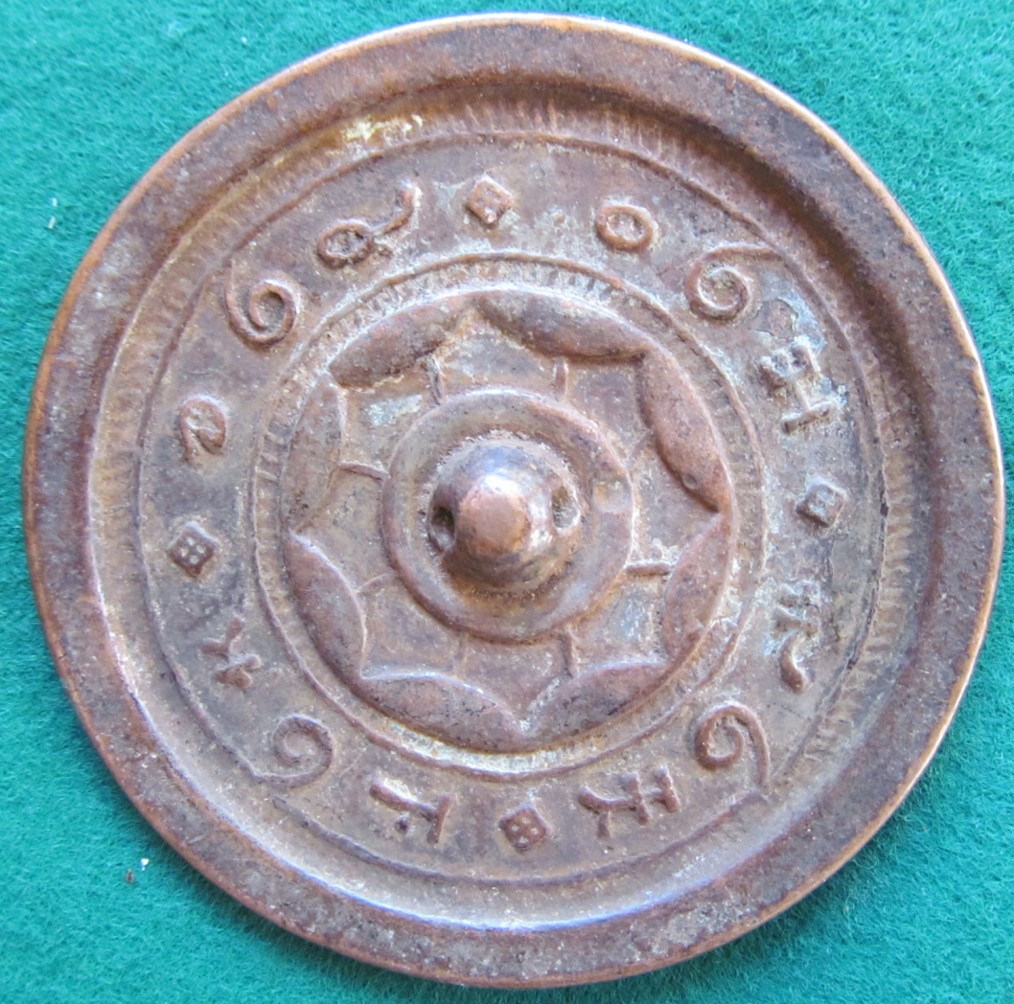

This mirror features a 12 character inscription broken into 4 three character sayings in ancient Shang script. Its 8 continuous arcs are linked with lines to the central boss..